TUTORIAL GNS3

Step 1: In the next URL, you can download the router ISO for make the simulation in GNS3:

<http://mikrotikperu.pe/foros/threads/instalando-gns3-con-ios-de-cisco-descarga-directa.88/>

Step 2: Start the GNS3 and put the name for the Project:

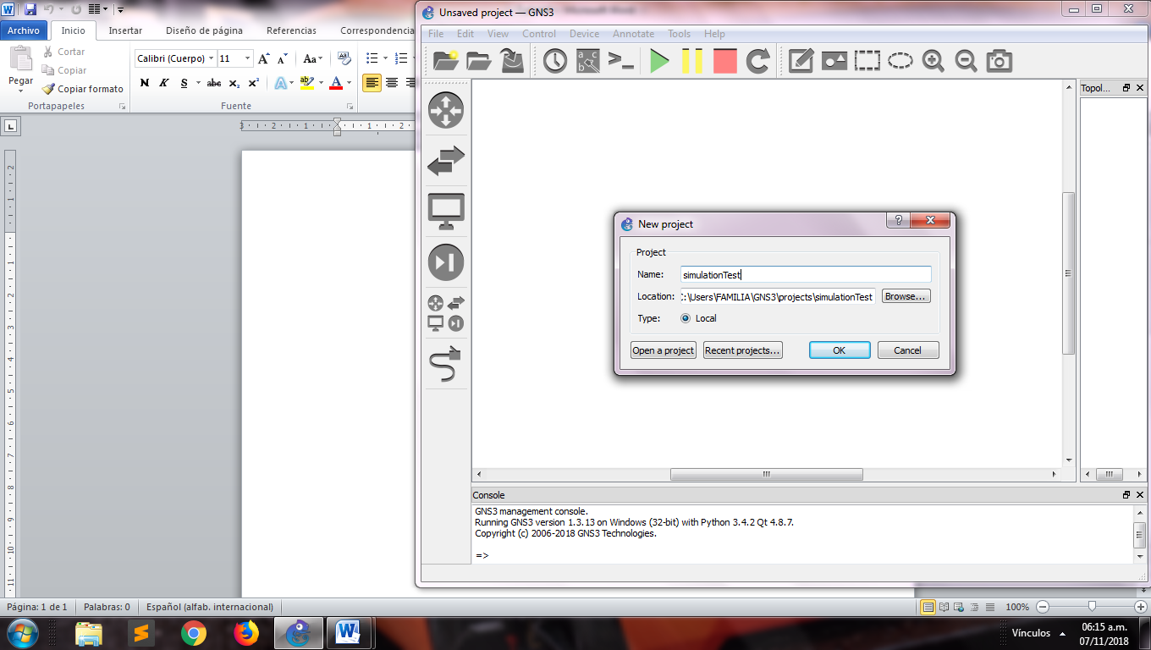

Step 3: In the menú bar click in edit > Preferences and it will show you the next window:

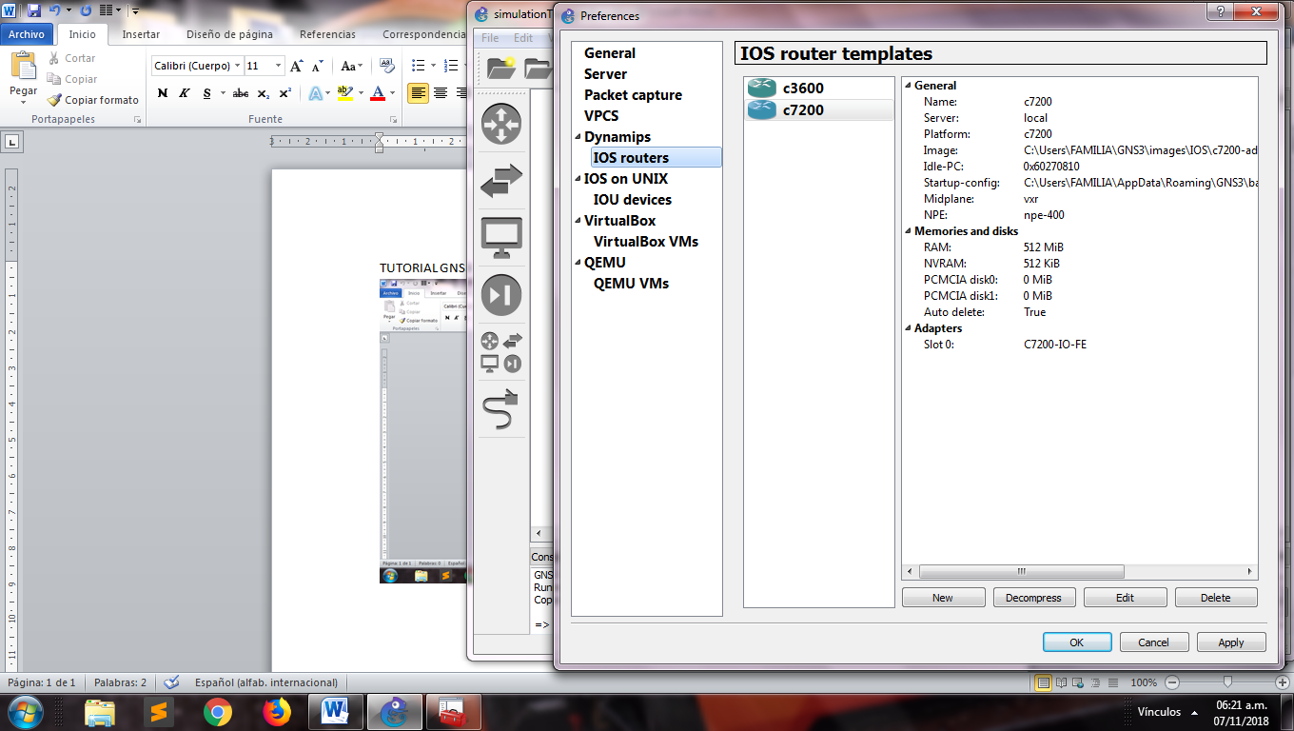

Step 4: click in IOS router and search the path of the router ISO and install it

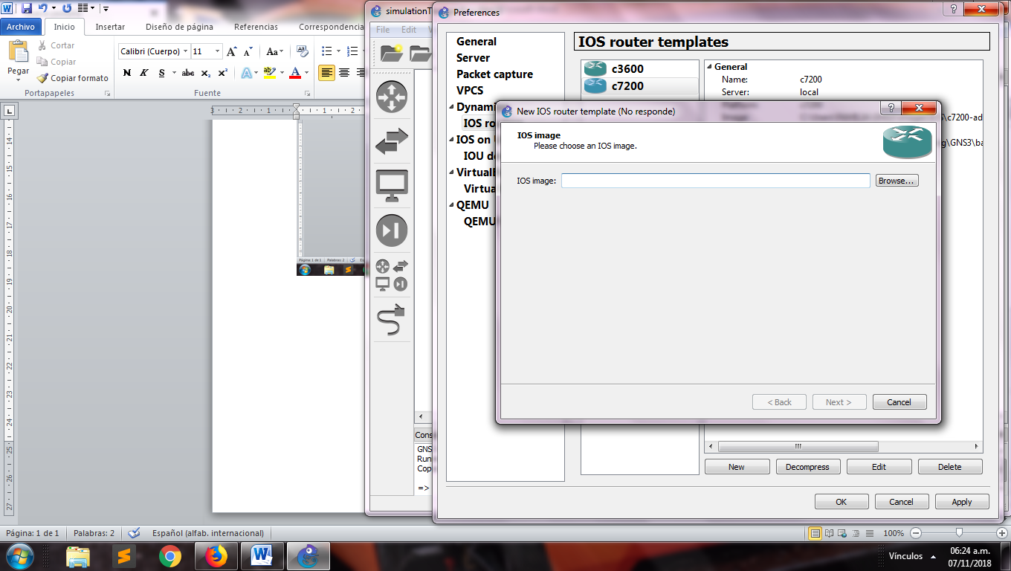

Step 5: Drag the router image over the workspace

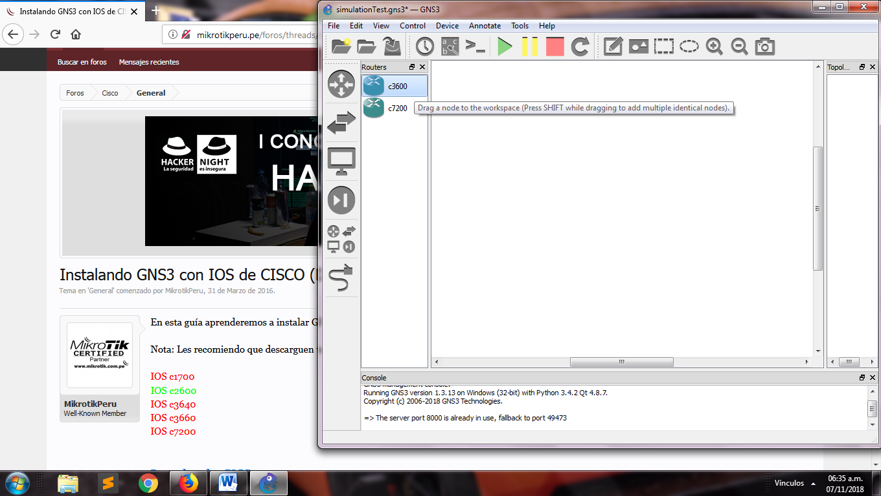

Step6: Configure the slots for each router

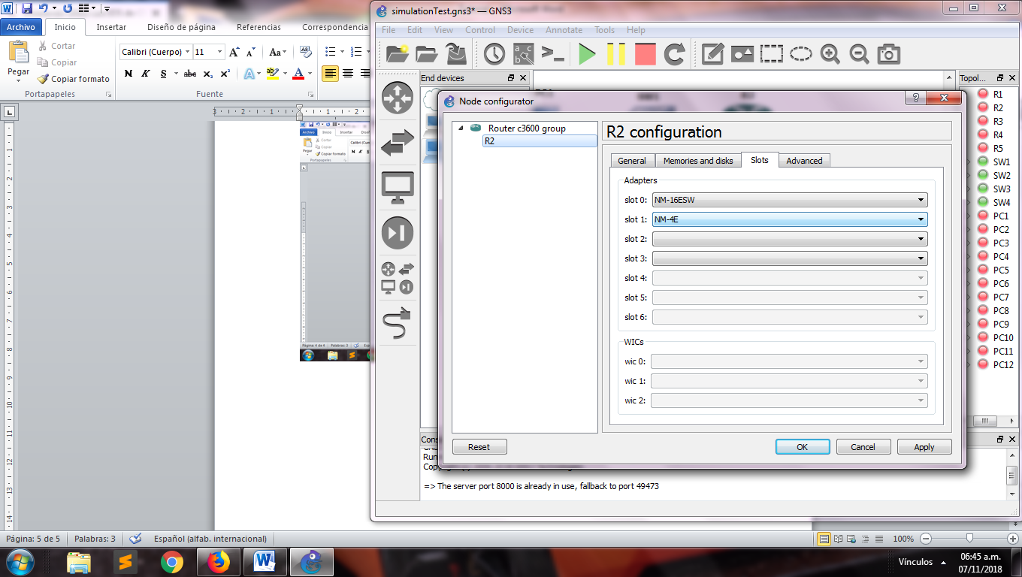

Step 7: Drag all the components that you need

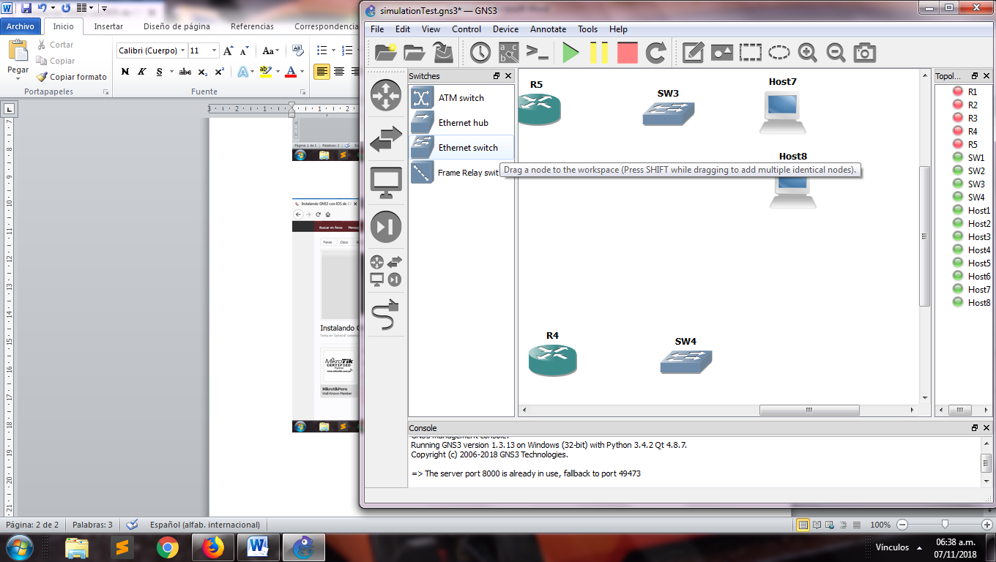

Step 8: Sort the components for department

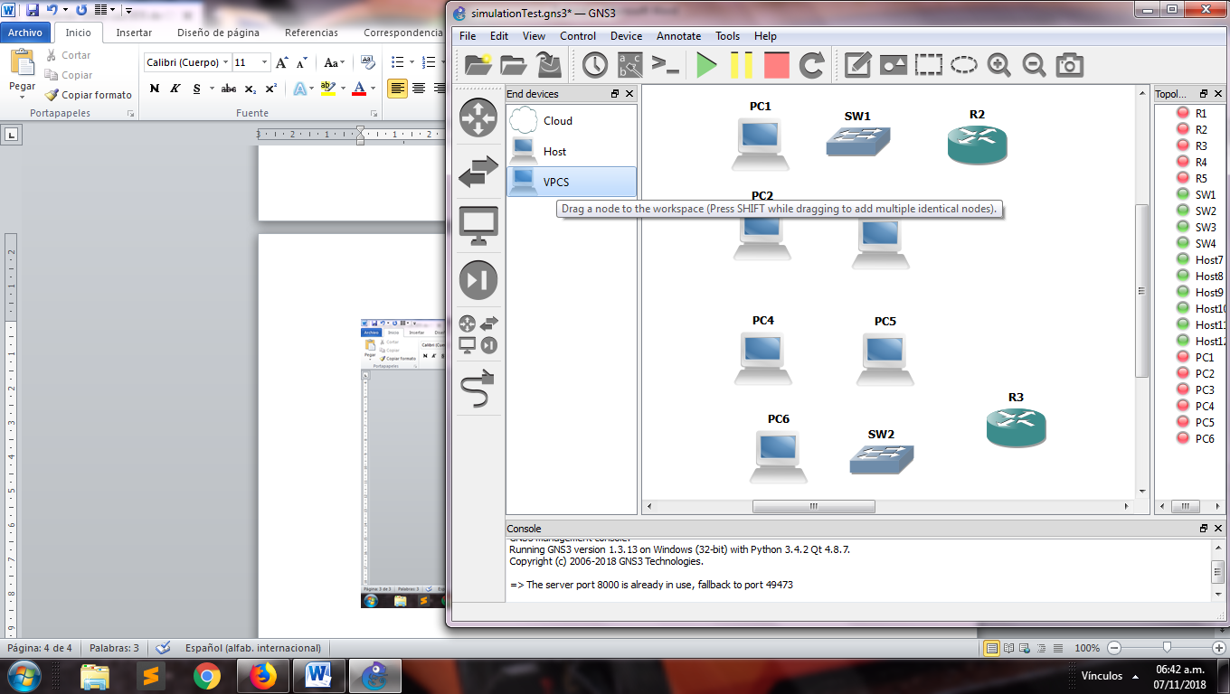

Step 9: Right click in the component and select “change symbol”

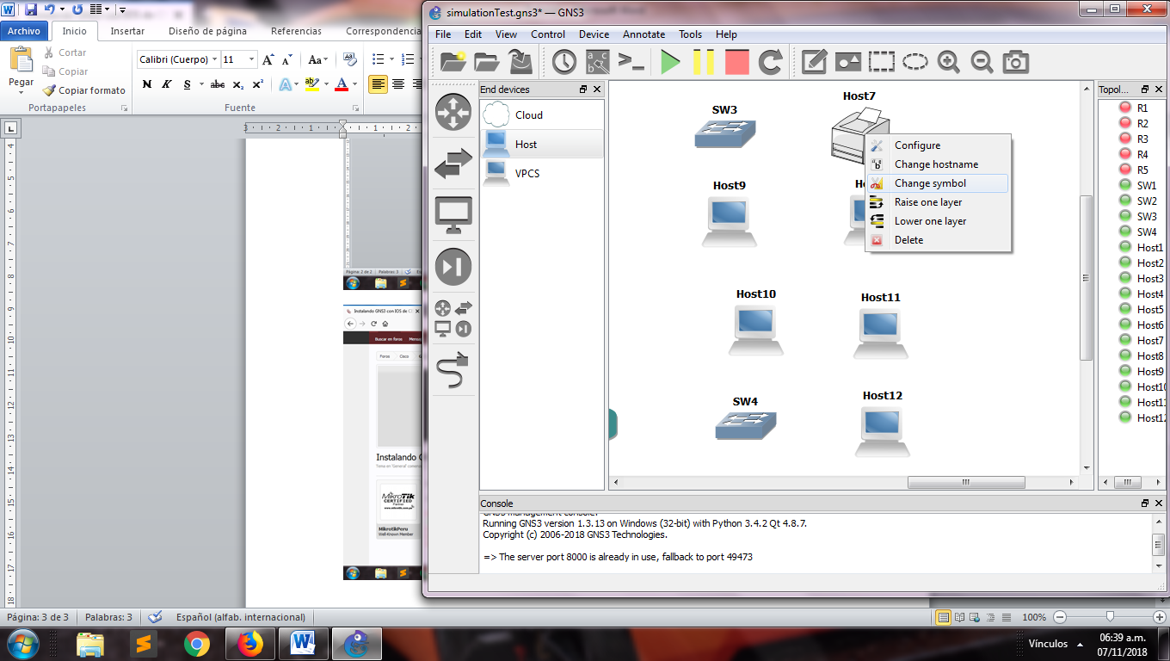

Step 10: Select the cable icon and connect the components for their interfaces

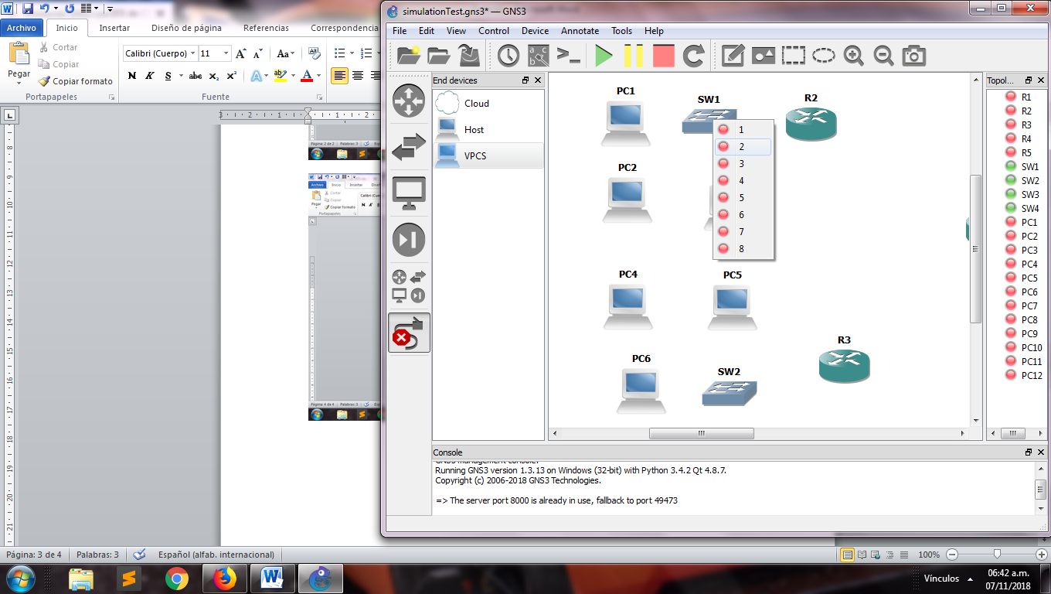 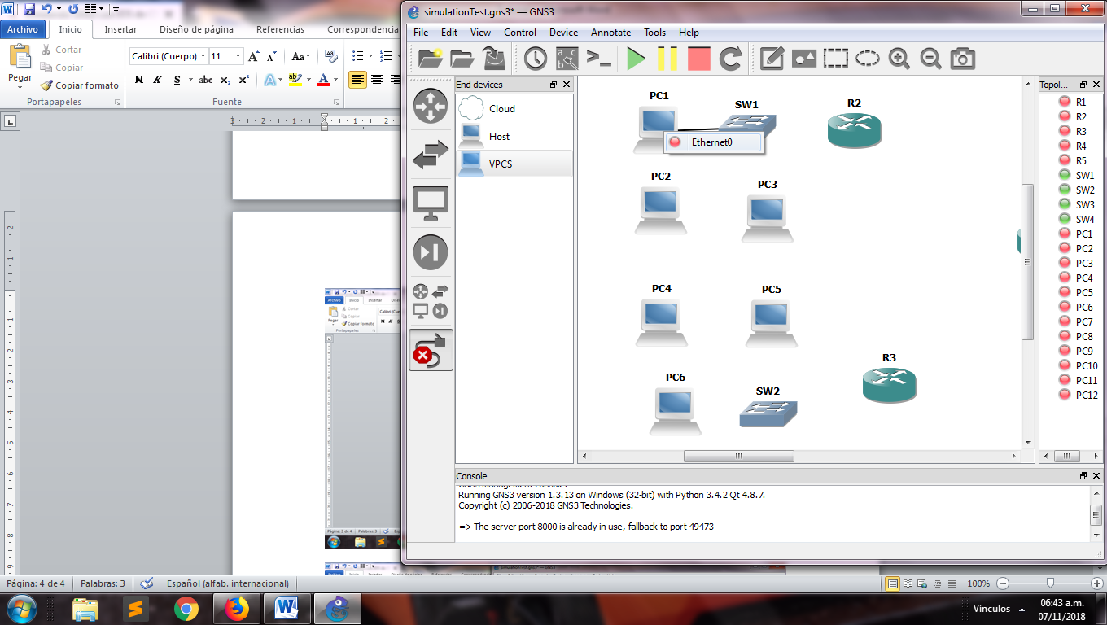

Step 11: Connect the department routers with the main router

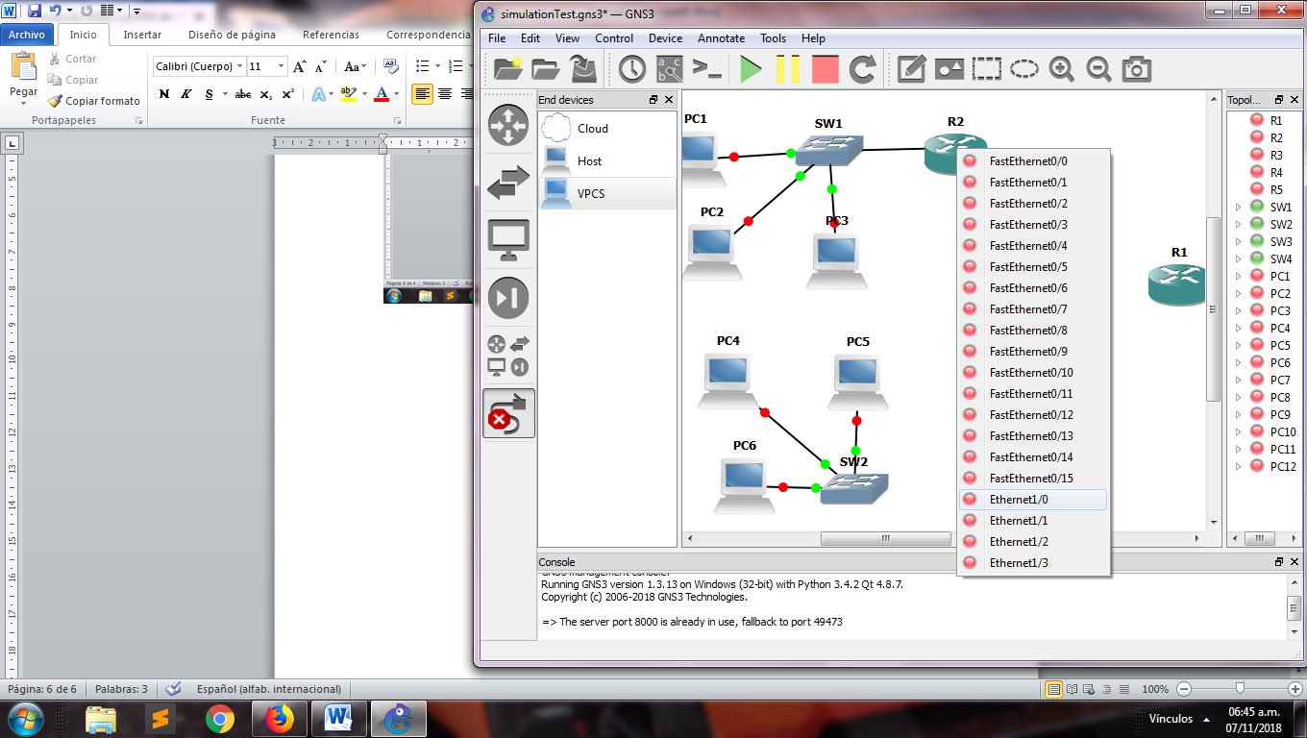

Picture: View of the network

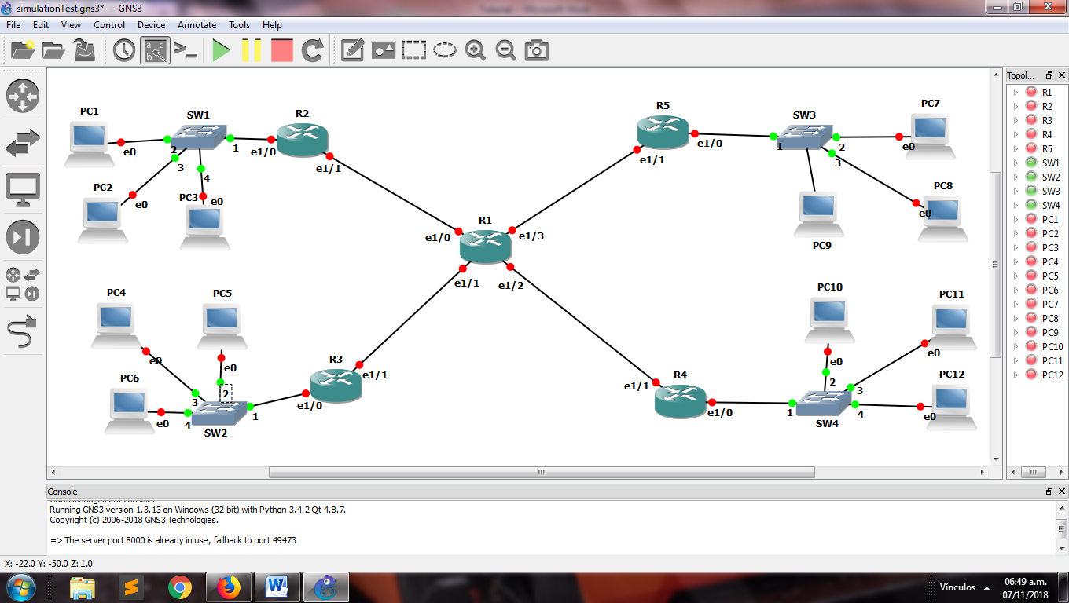

Step 12: Active the “Auto Idle-PC” for each router

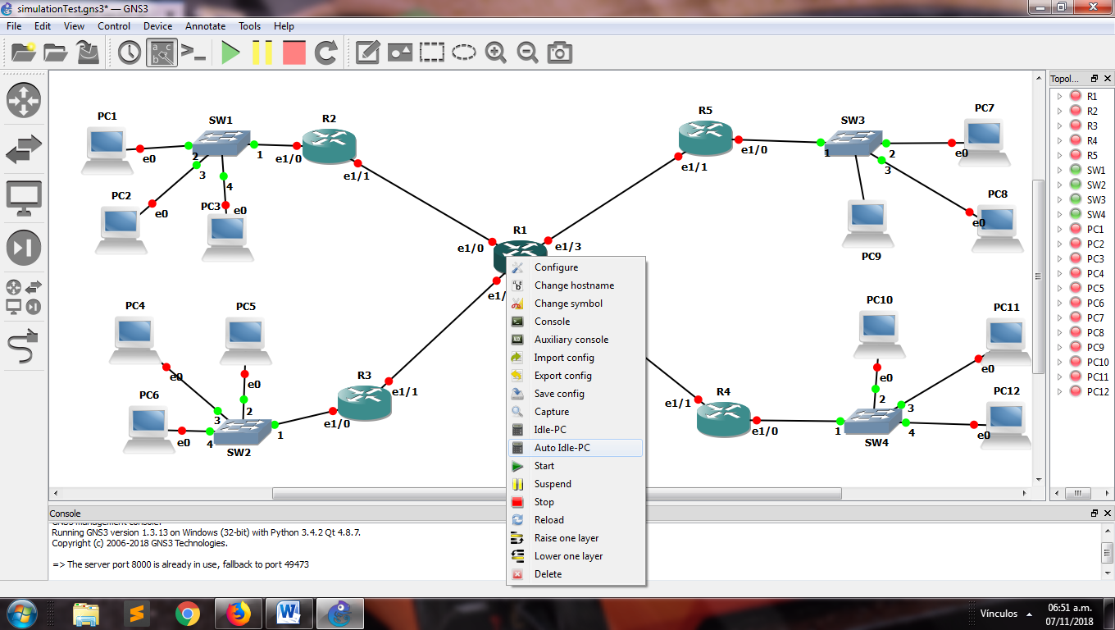

Step 13: Start the routers

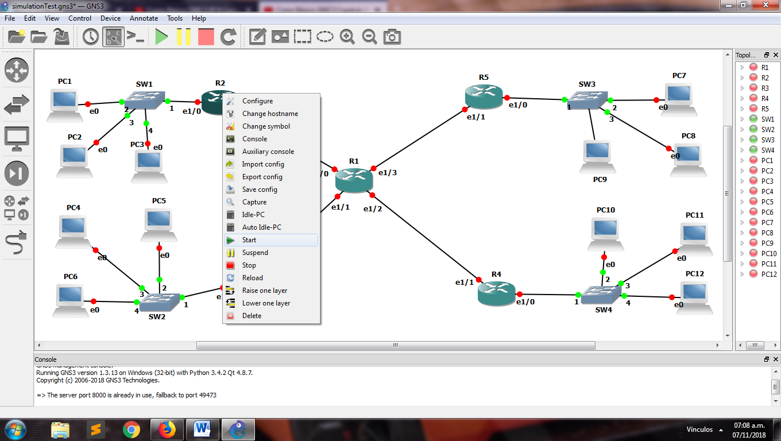

Step 14: In each router write the next lines:

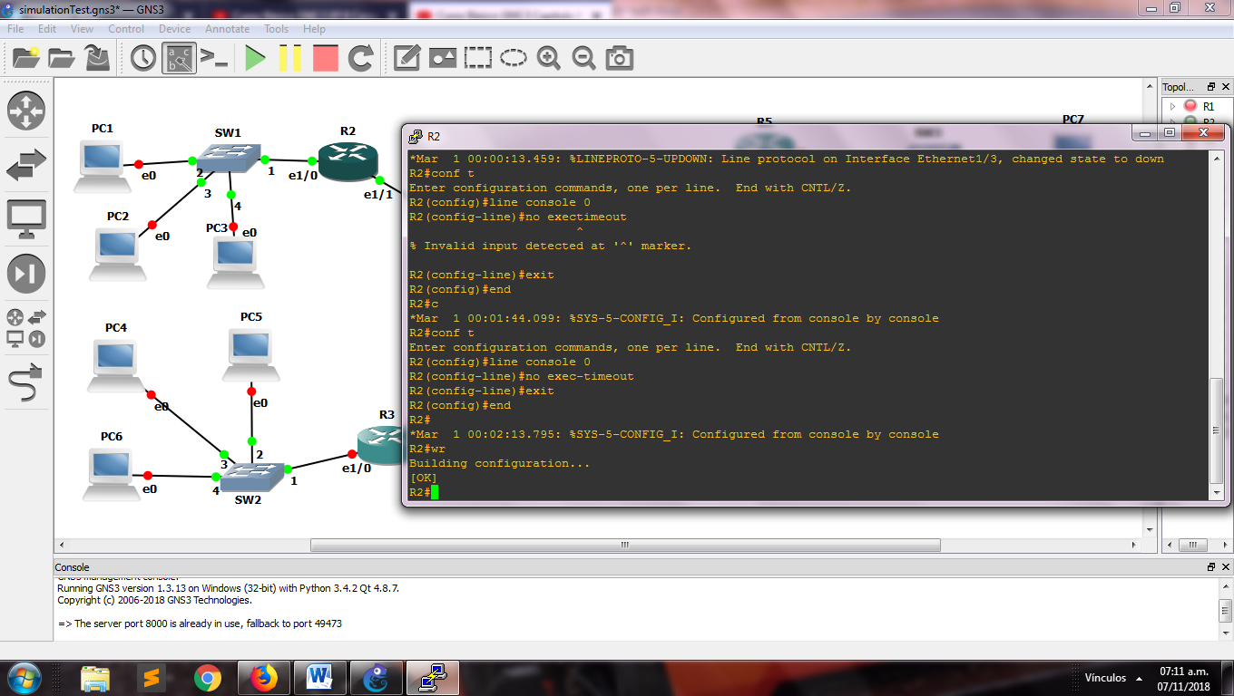

Step 15: Configure for each other the ip and the mask with the next lines:

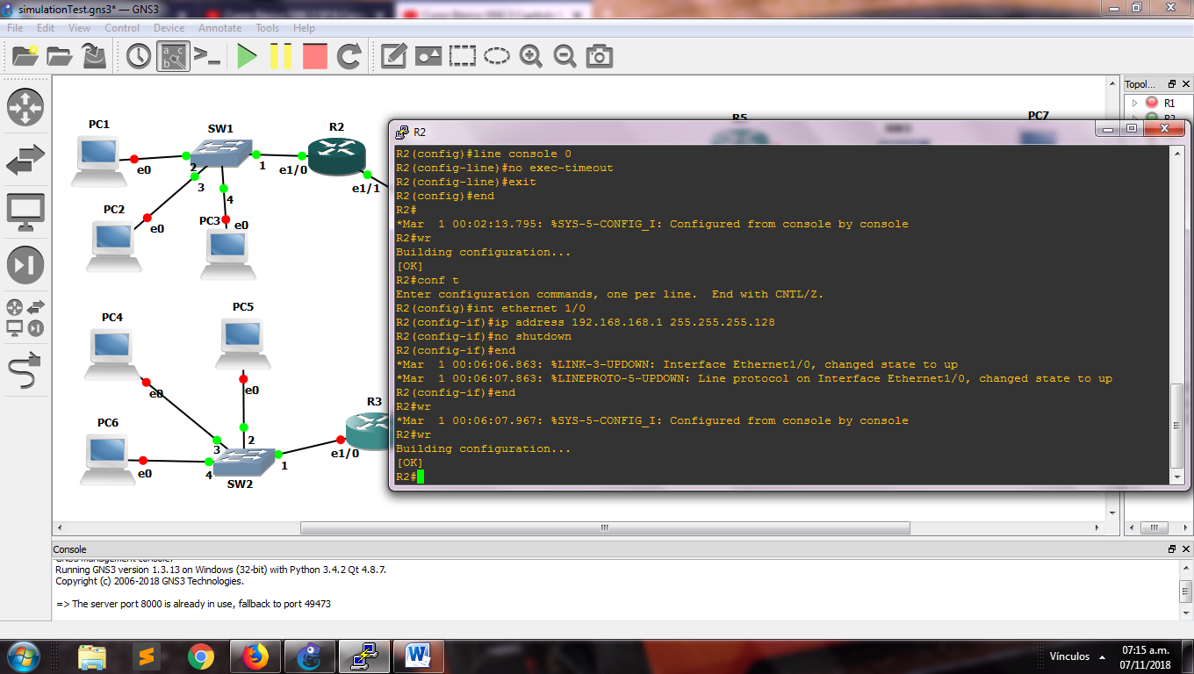

Step 16: Configure the dhcp pool for each router:

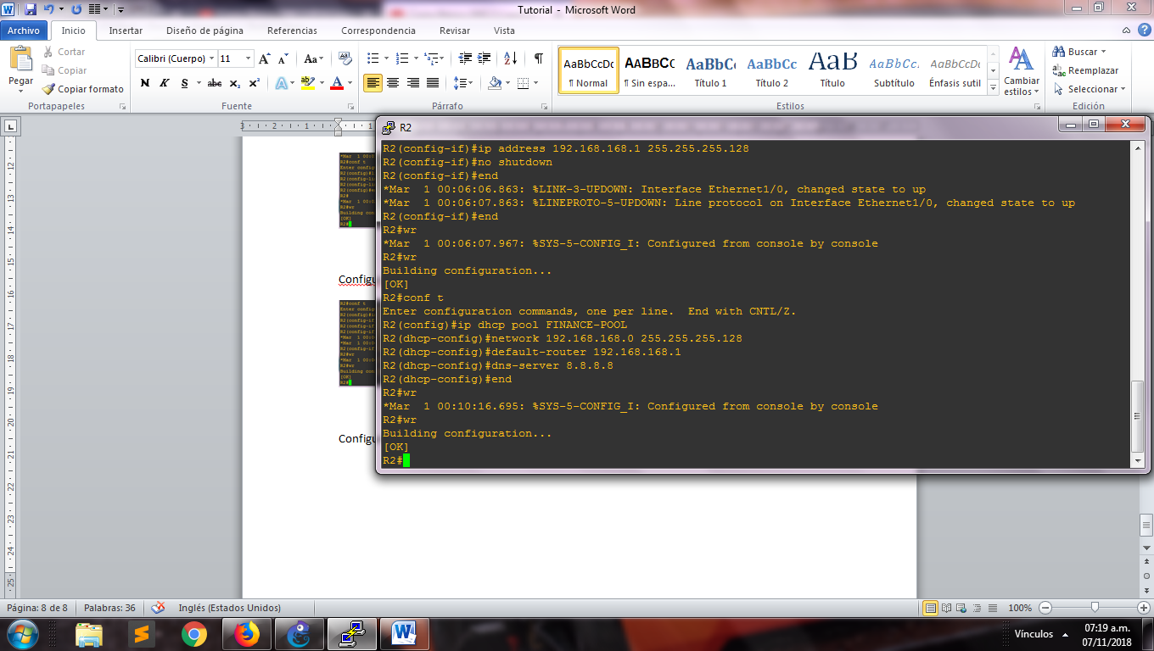

Step 17: Exclude any ips:

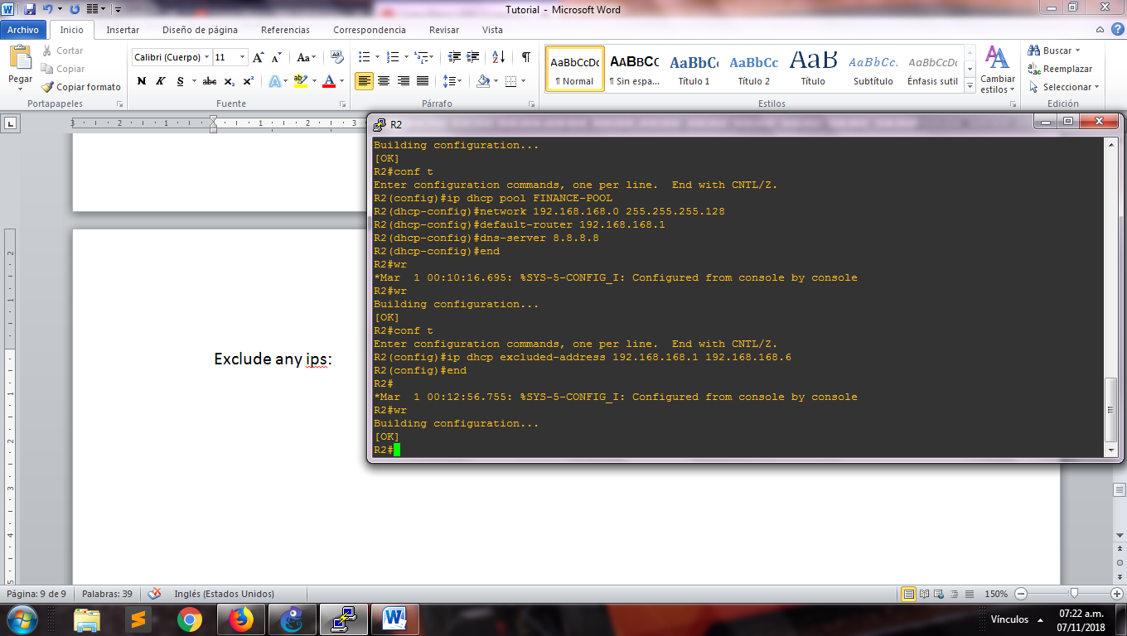

Step18: Try in the each host connects in the network:

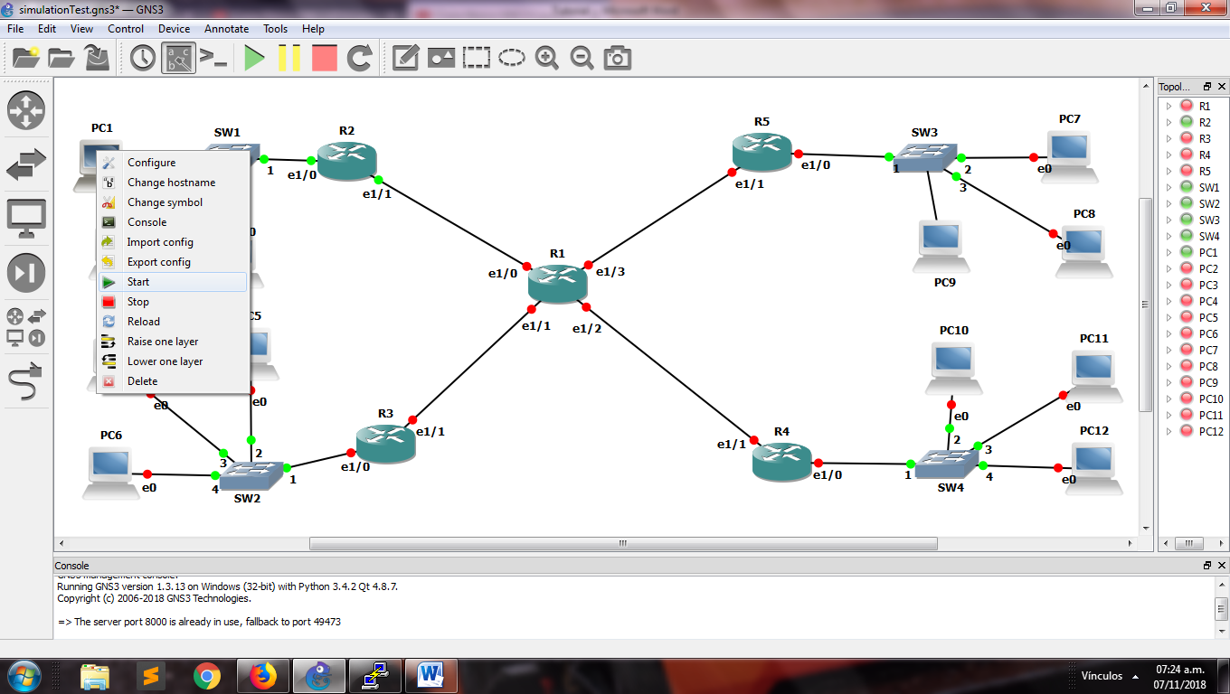

Step19: Apply for an ip address with the command “dhcp” in each pc

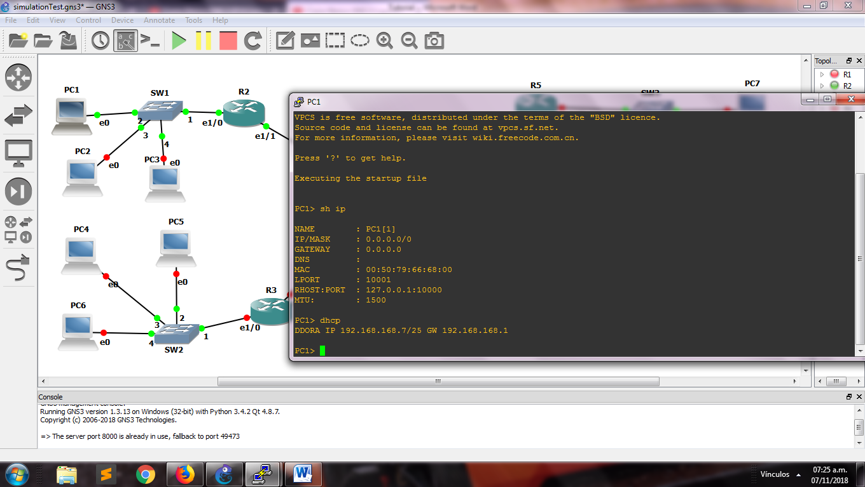

Step 20: Configure the ip address between R1 and R4 (router of the department)

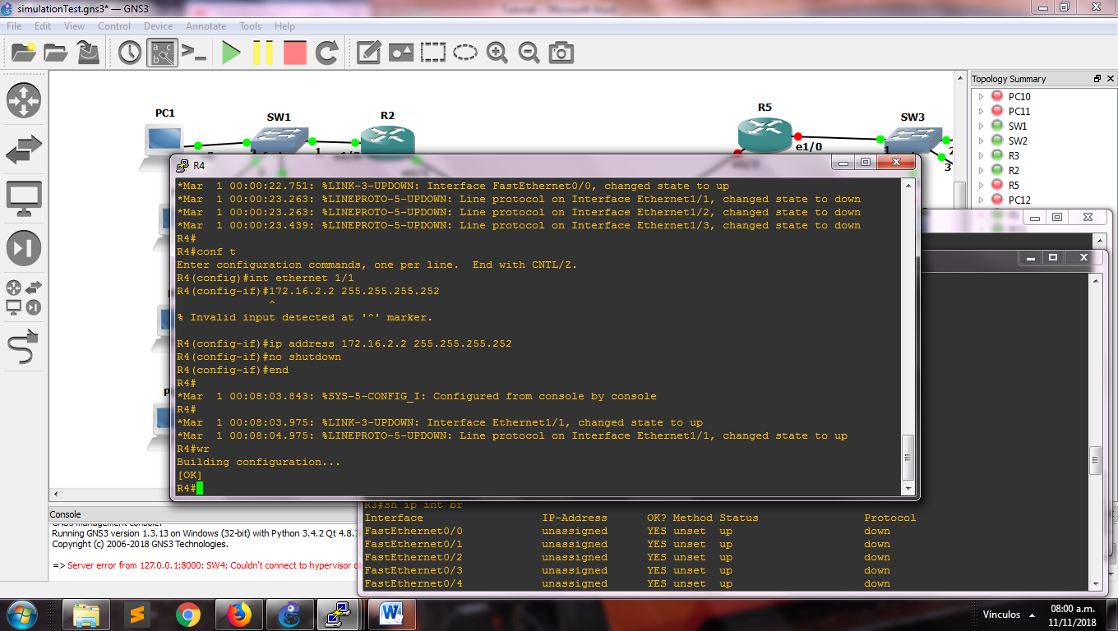

Step 21: Configure the main router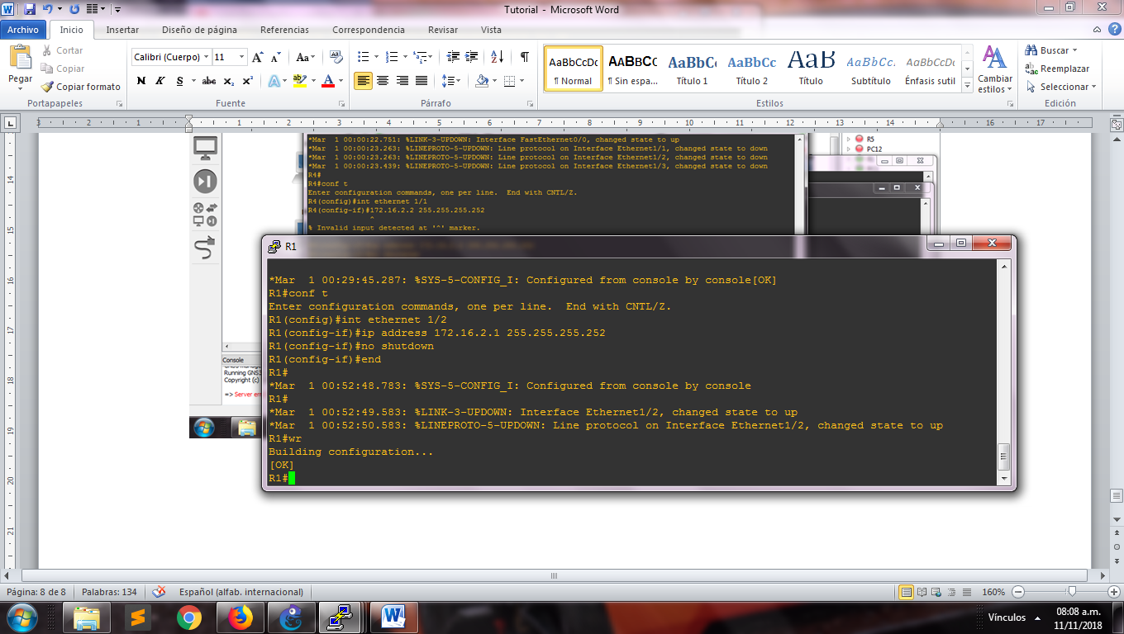

Step 22: Make ping between the routers for try the connection

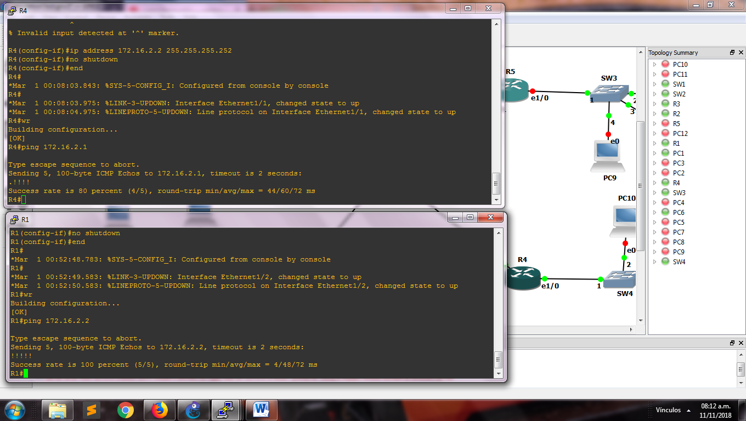

Step 23: Making the static route

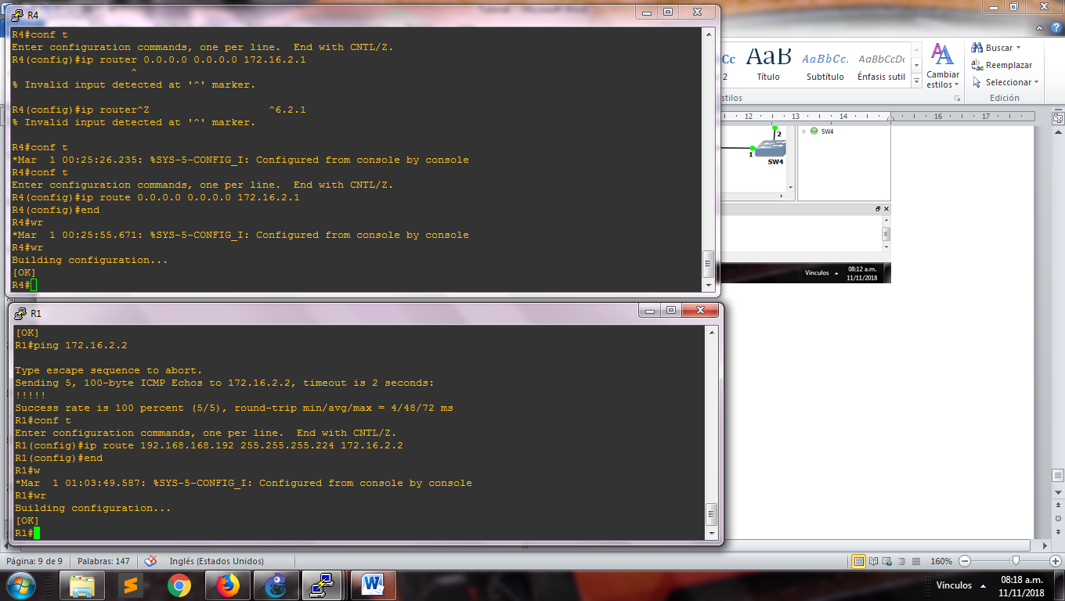

Step 24: Start the pc of the network and try the connection doing ping in the address

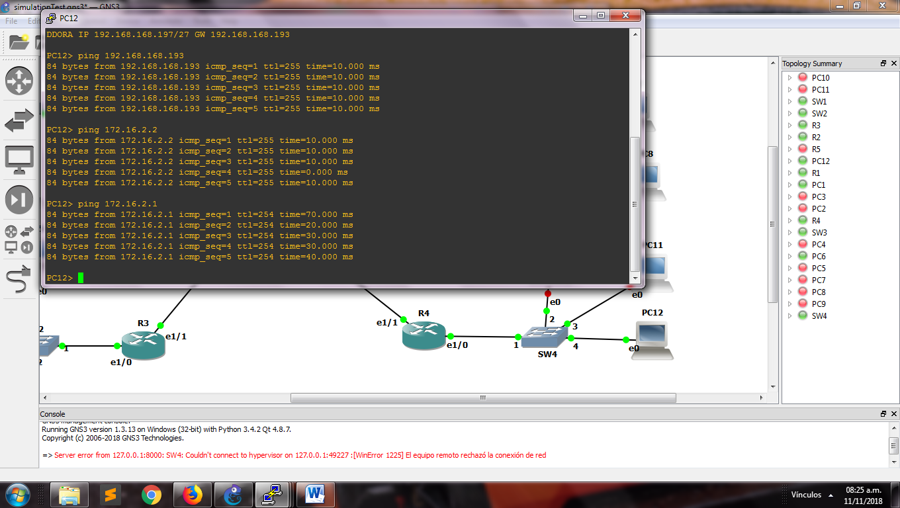

Step 25: We configure the outside interface

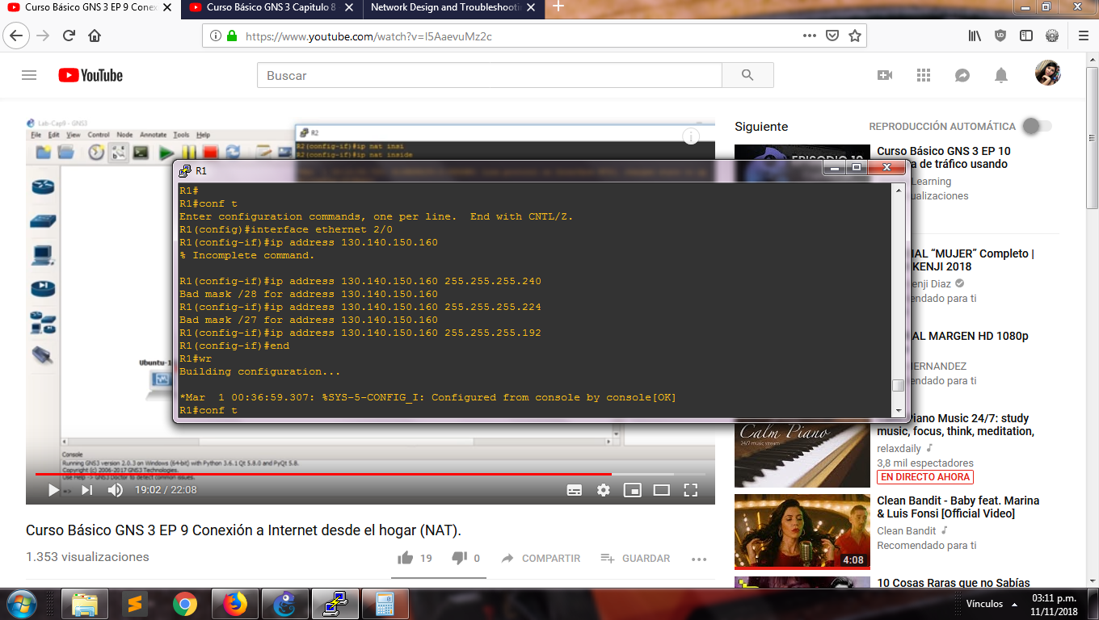

Step 26: Do NAT in the inside interfaces of the router

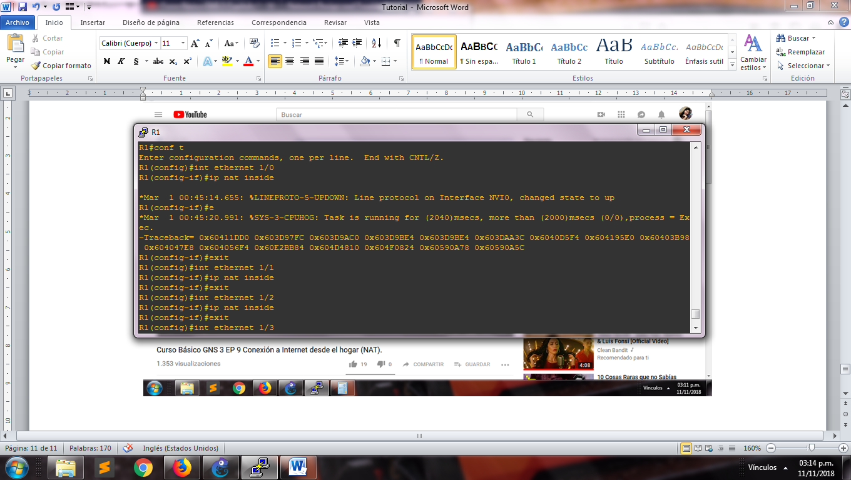

Step 27: We create the Access lists

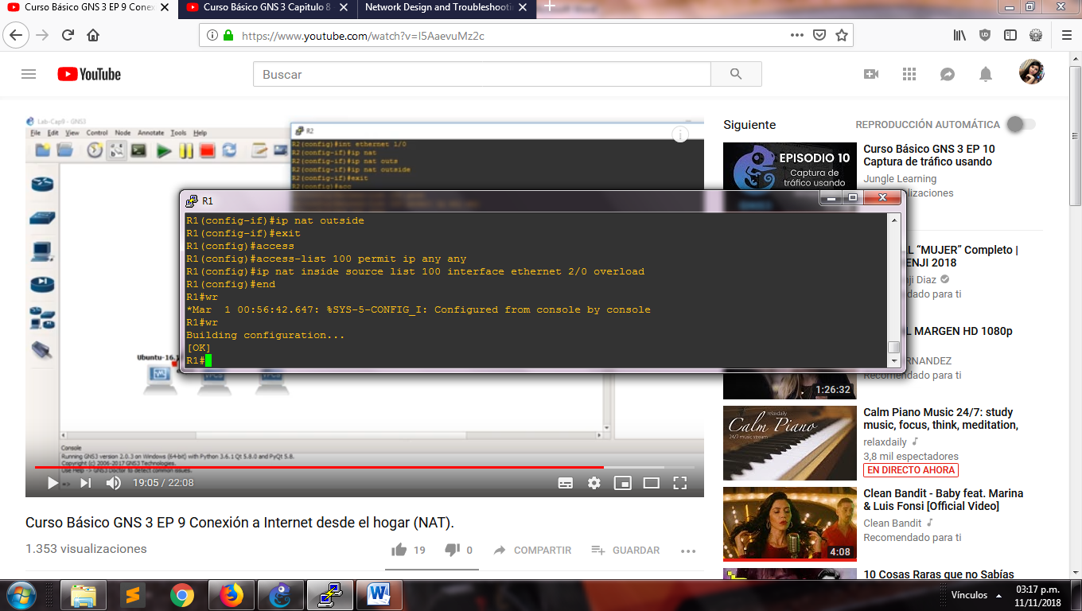

Step 28: Configure the internet Access:

a)Right click on the cloud and click on “Configure”

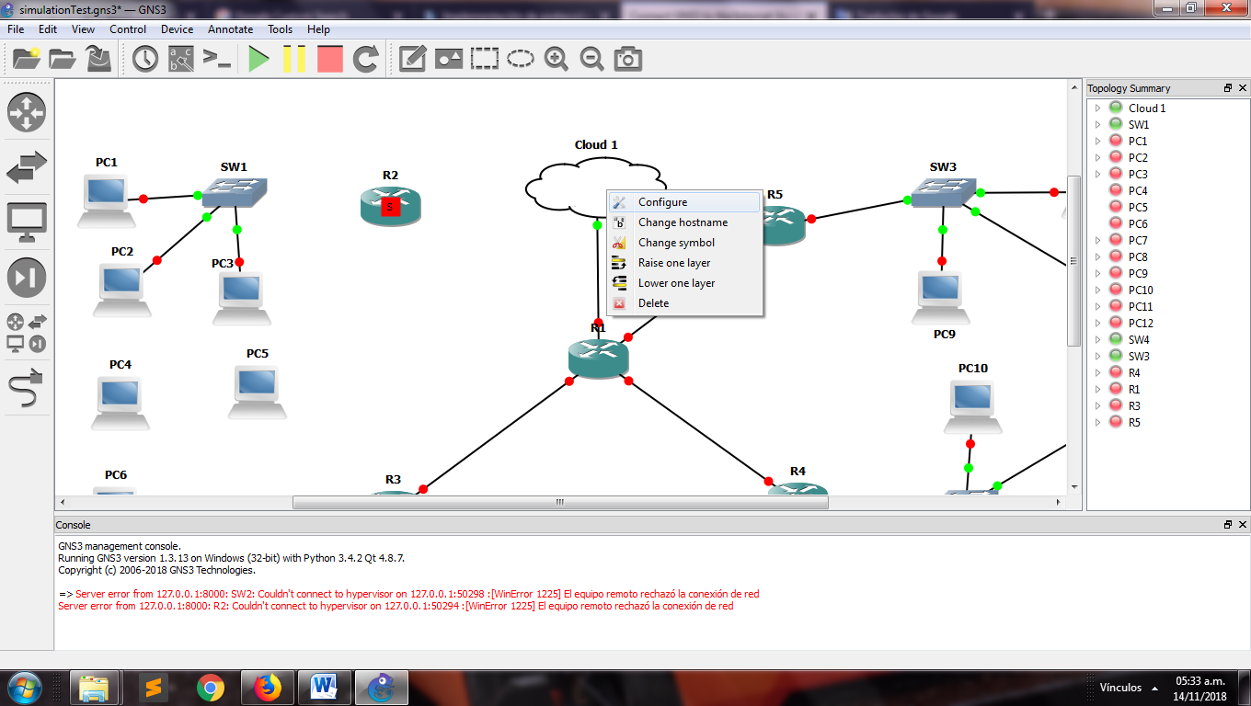

b) Select the network for the connection. Click on “Add” and click on “Ok”

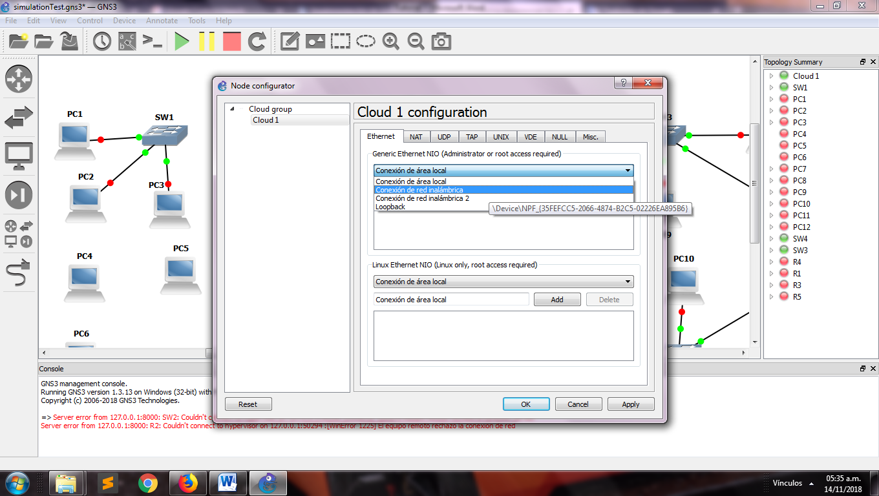

c) Enter in R1 and type the next lines for obtain an ip address, with that we assess the external connection with an ip real:

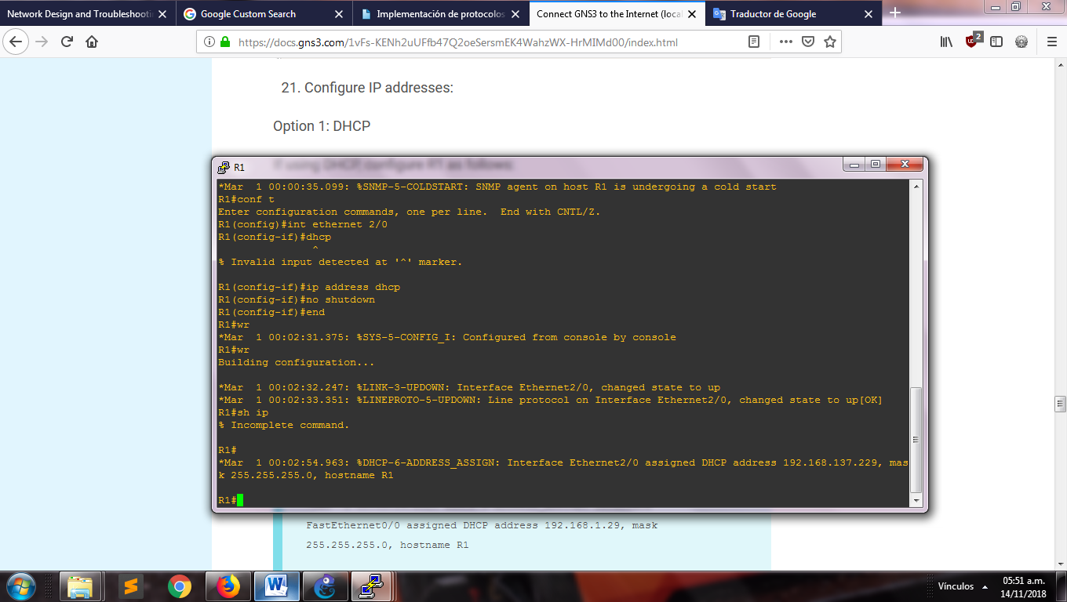

d) Configure the DNS server with the next lines:

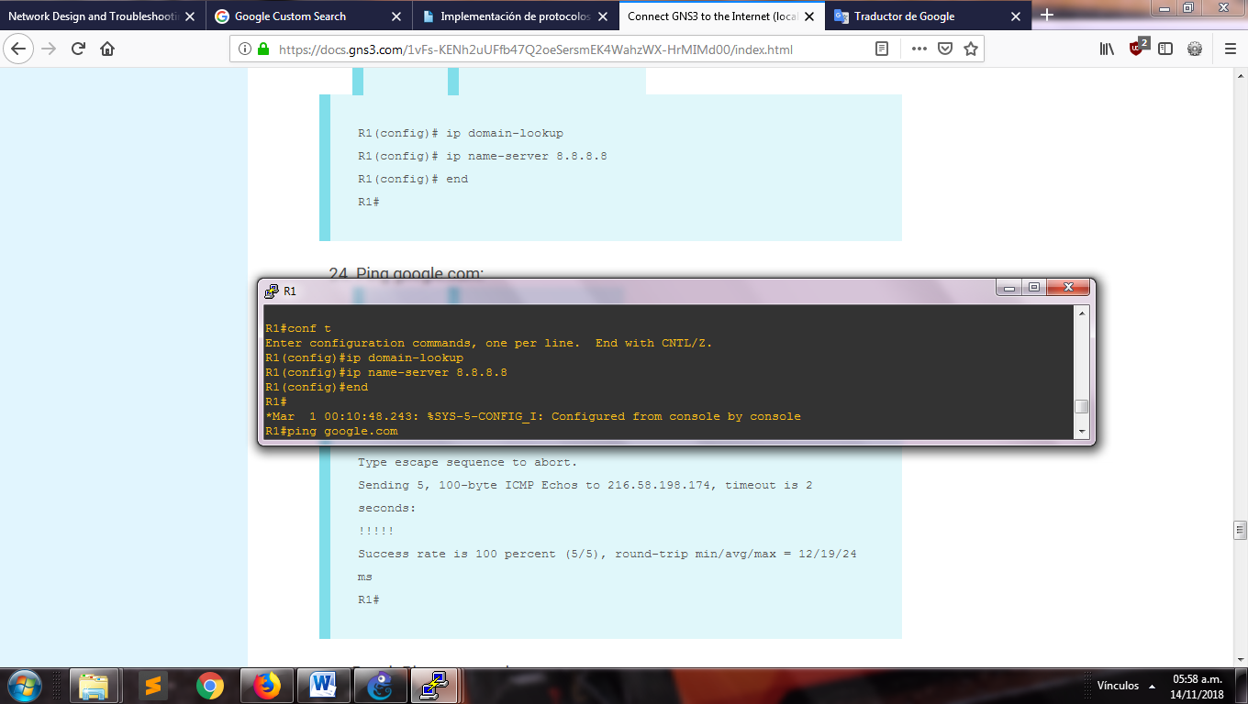

e) Configure the NAT

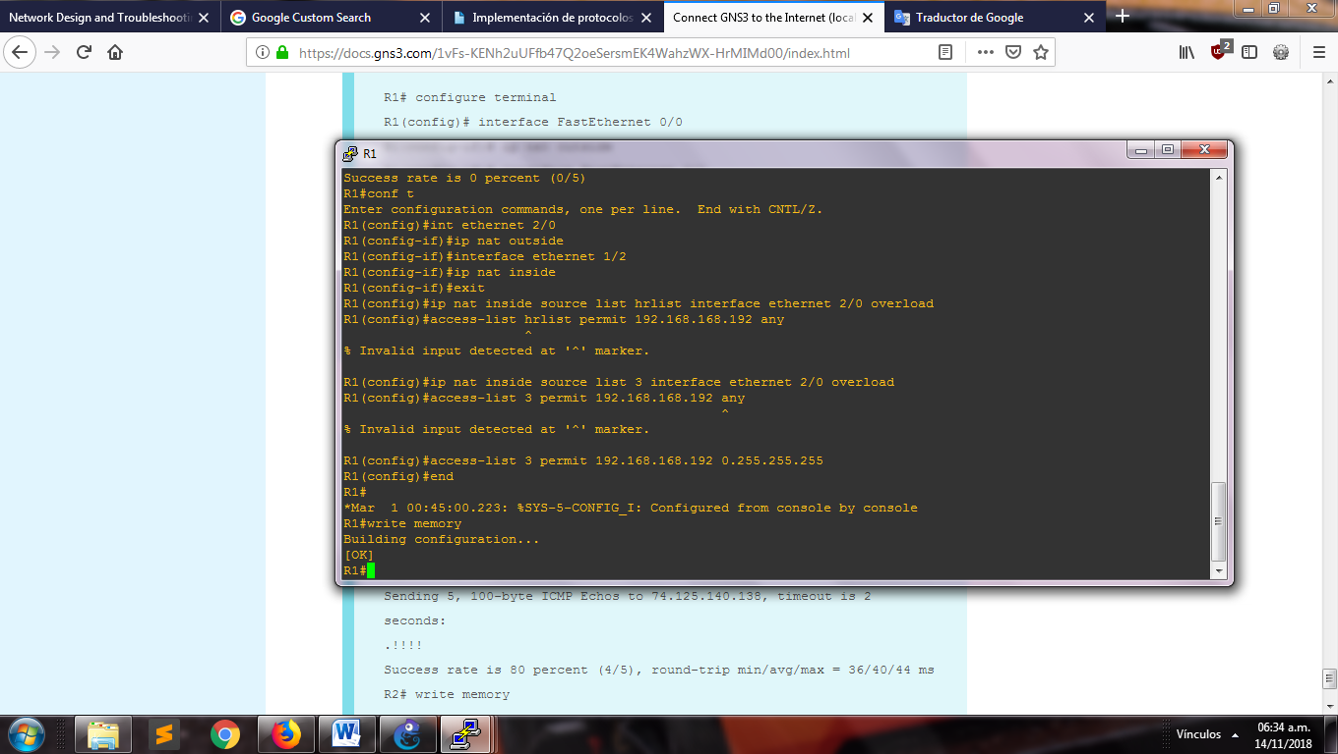

Step 29: Configure VLAN for each switch:

1. Right click in switch and next to “Configure”, put the port toward the router with VLAN 1 and type with “dot1q”, the next ports with type access.

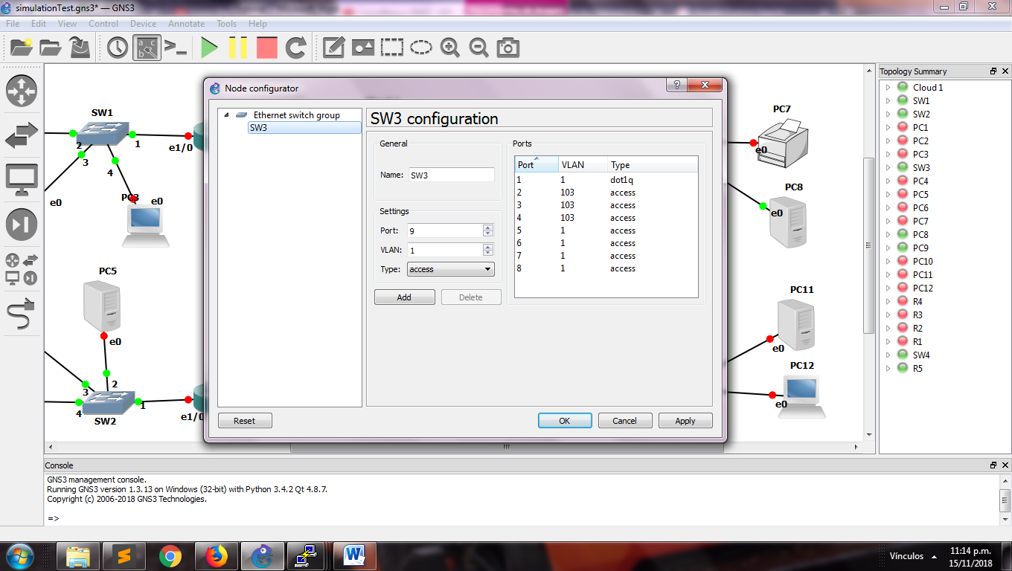

1. Configure the VLAN in each router

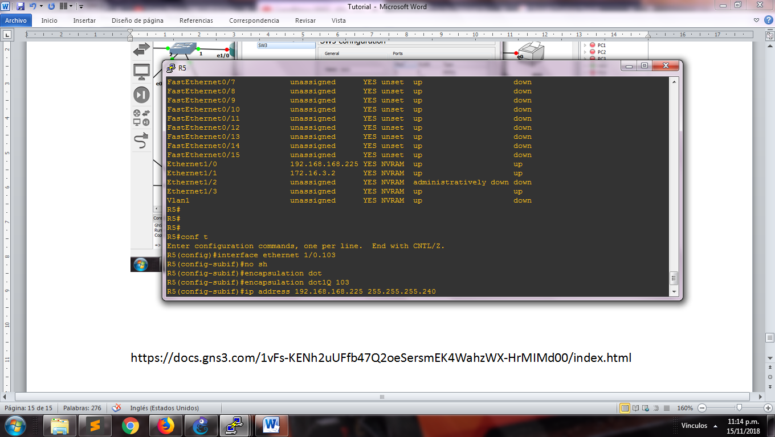

1. Add each VLAN inside the main router

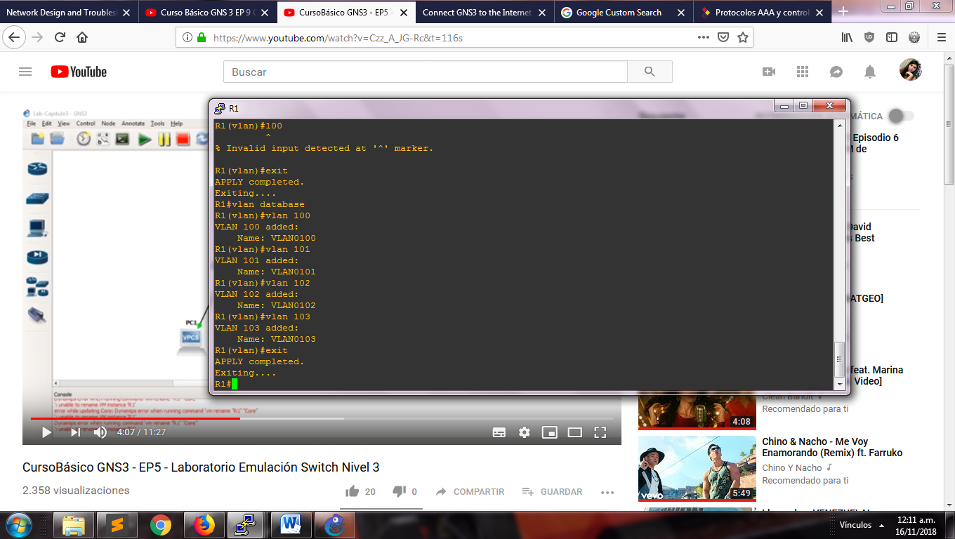

1. The command “sh vlan-switch” show the next table

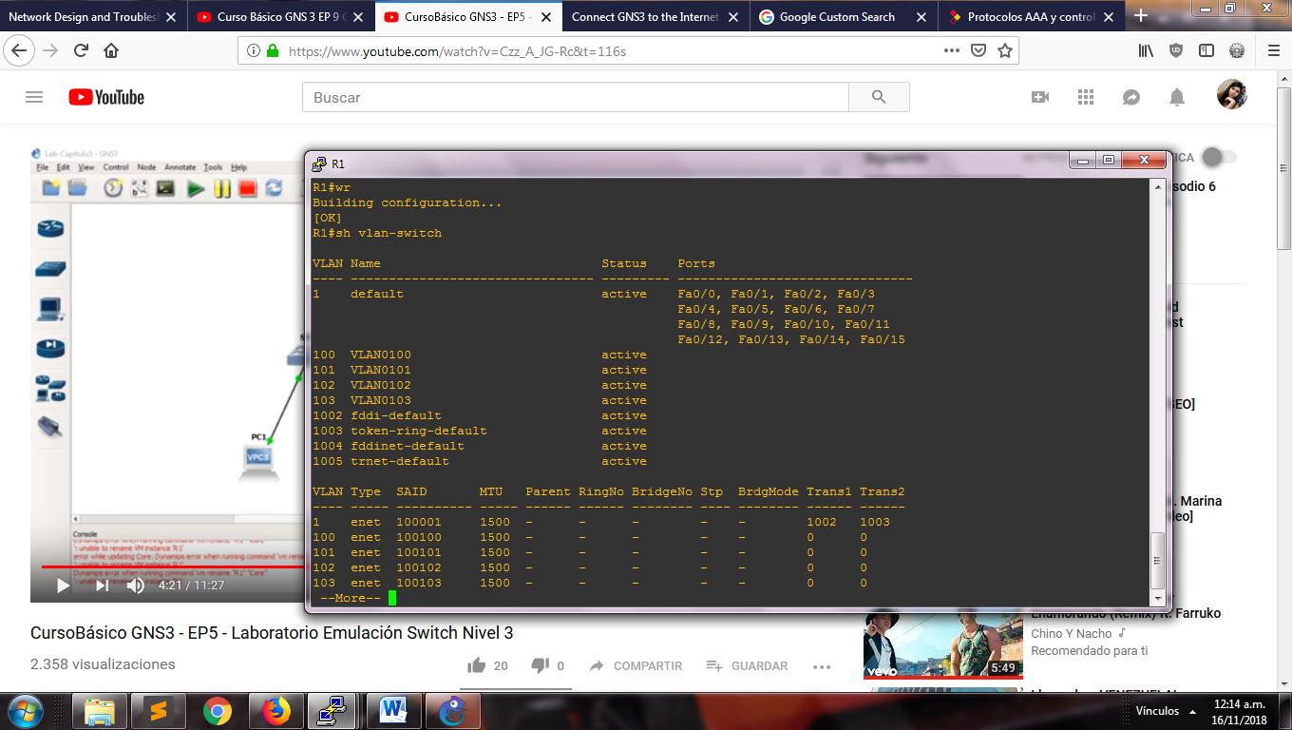

1. If you want, you can change the name of the VLANs with the next lines

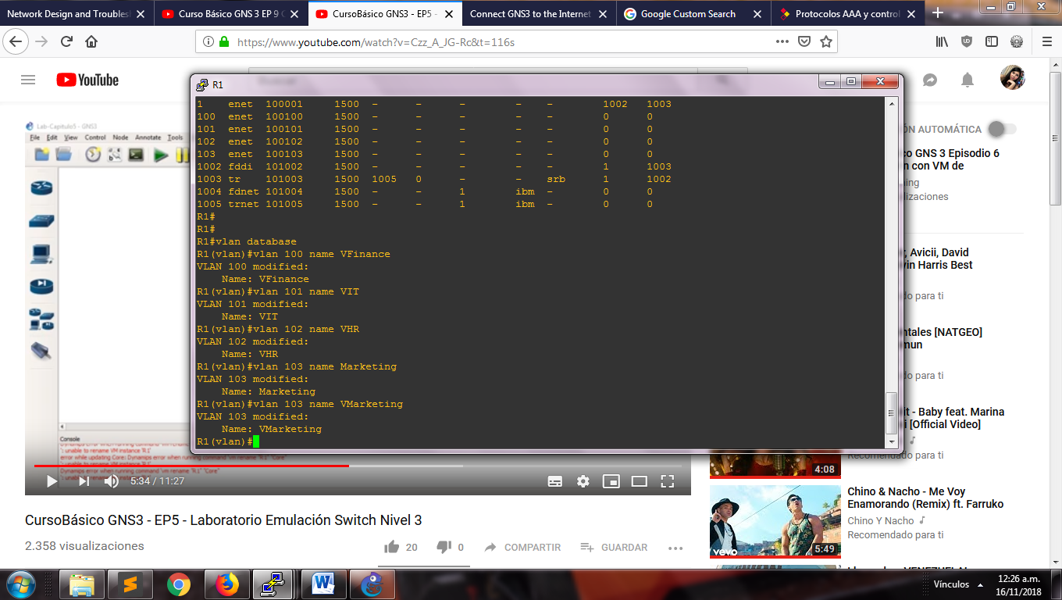

Picture: show the table with the new names in the VLANs

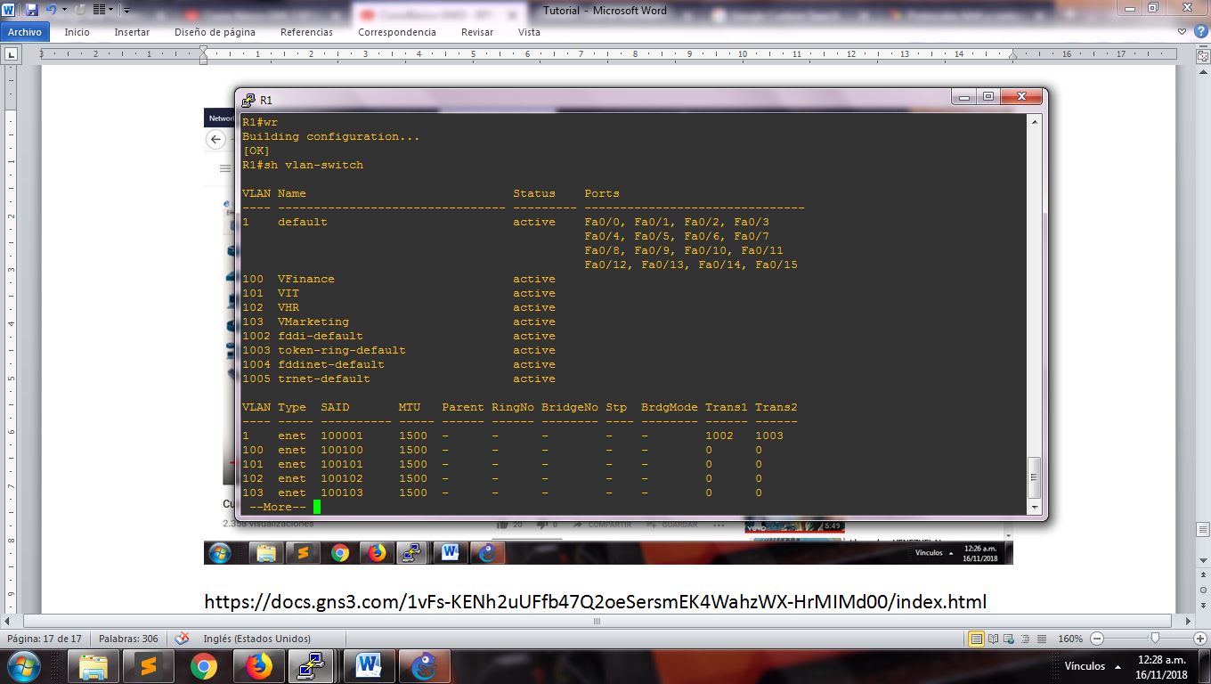

1. We configure the VLAN of each interface in the router R1:

